**Validate mode option in Copy into command**

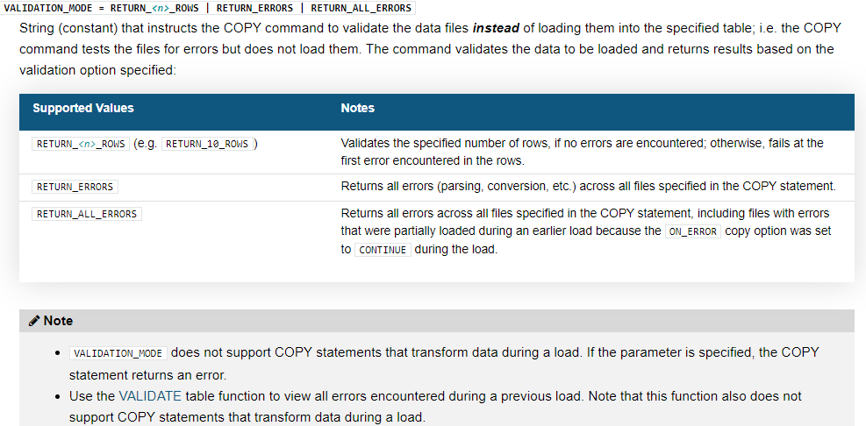

**RESULT_SCAN Table function**

Returns the result set of a previous command (within 24 hours of when you executed the query) as if the result was a table.

The command/query can be from the current session or any of your other sessions, including past sessions, as long as the 24 hour period has not elapsed.

select last_query_id(-2); -- 2nd most recent query_id

Retrieve all values from your second most recent query in the current session:

select * from table(result_scan(last_query_id(-2)));

Retrieve all values from your first query in the current session:

Select last_query_id(1); -- get first query of current session

select * from table(result_scan(last_query_id(1)));

Retrieve the values from the c2 column in the result of the specified query:

Result scan in comination with Describe and show commands

select c2 from table(result_scan('—pass queryid here --'));

desc user SKILLSCALER1;

select "property", "value" from table(result_scan(last_query_id()))

where "property" = 'DEFAULT_ROLE';

**Extract empty tables that are older than 21 days from show command**

show tables;

-- Show the tables that are more than 21 days old and that are empty

-- (i.e. tables that I might have forgotten about).

select "database_name", "schema_name", "name" as "table_name", "rows", "created_on"

from table(result_scan(last_query_id()))

where "rows" = 0 and "created_on" < dateadd(day, -21, current_timestamp())

order by "created_on";

# VALIDATE Table function

Validates the files loaded in a past execution of the [COPY INTO <table>](https://docs.snowflake.com/en/sql-reference/sql/copy-into-table.html) command and returns all the errors encountered during the load, rather than just the first error.

select * from table(validate(<table_name>, job_id=><query_id_of_the_copy_command>));

JOB_ID => query_id

select * from table(validate(emp, job_id=>'_last'));

If _last is specified instead of query_id, the function validates the last load executed during the current session, regardless of the specified target table.

This function does not support [COPY INTO <table>](https://docs.snowflake.com/en/sql-reference/sql/copy-into-table.html) statements that transform data during a load.

The validation returns no results for COPY statements that specify ON_ERROR = ABORT_STATEMENT (default value).